M 029
MODEL PAPER
B.E. DEGREE EXAMINATION.
Fourth Semester
Civil Engineering
CE 236 — STRENGTH OF MATERIALS
Time : Three hours Maximum : 100 marks
Answer ALL questions.
PART A — (10 × 2 = 20 marks)
- Calculate the strain energy stored in a bar 2 m long, 50 mm wide and 40 mm thick, when it is subjected to a tensile load of 50 kN. Take E = 200 GPa.
- A rectangular body 500 mm long, 100 mm wide and 50 mm thick subjected to a shear stress of 80 MPa. Determine the strain energy stored in the body.
Take N = 85 GPa.
- A fixed beam AB of 5 m span carries a point load of 20 kN at a distance of 2 m from left support. Determine the deflection under the load, if $\text{EI} = \text{10} × {\text{10}}^{3}$kN–m².
- A beam AB of span 3 m is fixed at A and propped at B. Find the reaction at the prop. when it is loaded with a uniformly distributed load of 20 kN/m over its entire span?
- Define ‘‘buckling load’’.
- Write the effective length of column for the following end conditions :
(a) Both ends pinned condition
(b) Both ends fixed condition.
- The internal pressure of a stream drum is 10 N/mm². The maximum circumferential stress is 85 N/mm² and maximum longitudinal stress is
22 N/mm². Find the equivalent tensile stress in a simple tensile test according to the maximum shear stress theory.
- State strain energy theory.
- A channel section has flanges 120 mm × 20 mm and web 160 mm × 10 mm. Determine the shear centre of the channel.
- List the reason for unsymmetrical bending.
PART B — (5 × 16 = 80 marks)
- Find the vertical displacements of joint V₁ of the frame shown in Fig. 11. due to applied loadings. Take $E = 2 × {\text{10}}^{5}$ N/mm² and Area of members 1200 mm².
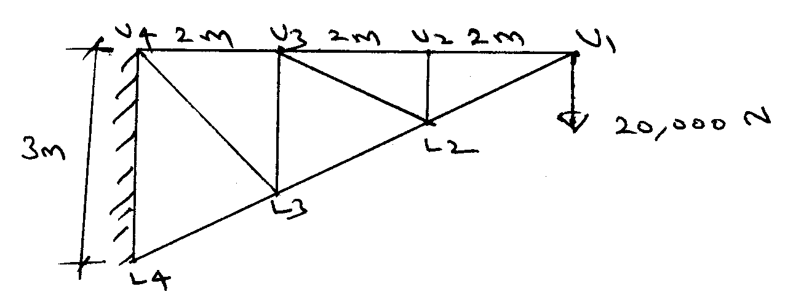
Fig. 11.
- (a) Find by Maculay’s method, the central deflection of a fixed beam loaded with uniformly distributed load throughout the span.
Or
(b) A continuous beam ABC consists of two spans AB and BC of lengths 6 m and 8 m. The span AB carries a point load of 120 kN at 4 m from A while the span BC carries a point load at 5 m frame. Find the moments and reactions at supports. Draw SFD and BMD.
- (a) A 2 m long pin ended column of square cross section is to be made of wood. Assuming E = 12 GPa and allowable stress being limited to
12 MPa, determine the size of the column to support the following loads safely.
(i) 95 kN (ii) 200 kN.
Use factor of safety of 3 and also calculate the Euler’s crippling load for buckling.
Or
(b) A hollow cast iron column whose outside diameter is 200 mm and has a thickness of 20 mm is 4.5 m long and is fixed at both ends. Calculate the safe load by Rankine’s formulae using a factor of safety of 2.5. Find the ratio of Euler’s to Rankine’s loads. Take $E = 1 × {\text{10}}^{5}$N/mm² and Rankine’s constant = $\frac{1}{\text{1600}}$ and $f_{c} =$550 N/mm².
- (a) A hollow shaft 30 mm internal diameter and 50 mm external diameter is subjected to a twisting moment of 800 Nm and an axial compressive force of 40 kN. Determine the factor of safety according to strain energy theory, if the yield strength of material is 280 N/mm² and Poisson’s ratio is 0.3.
Or
(b) The load on a bolt consists of an axial thrust of 8 kN together with a transverse shear force of 4 kN. Calculate the diameter of the bolt according to
(i) Maximum principal stress theory and
(ii) Maximum shear stress theory.
Take F.O.S. = 3, typ = 285 N/mm² $g \frac{1}{m} = 0\text{.}3$.
- (a) A curved beam has a T–section as shown in Fig. 15 (a). The inner radius is 300 mm. What is the eccentricity of the section?
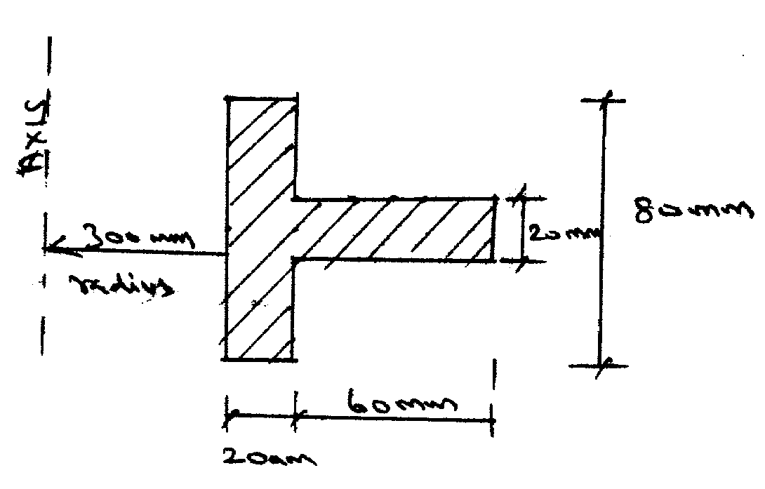
Fig. 15 (a)
Or
(b) A thick pipe of 300 mm outer diameter and 200 mm internal diameter is subjected to an internal pressure of 12 MPa. What minimum external pressure can be applied so that the tensile stress in the metal shall not exceed 16 MPa?

———————

